CSV vs JSON vs XML – The Best Comparison Guide 2026

CSV vs JSON vs XML – The Best Comparison Guide 2026: CSV vs JSON vs XML: Key Differences & Comparison Guide 2026
CSV, JSON, AND XML FILES: Chapter 18 - CSV, JSON, and XML Files, Automate the Boring Stuff with Python, 3rd Ed

Key Takeaways

  - As you’ll see, picking CSV, JSON, or XML for your data file’s format depends on your application’s specific needs, things like data complexity, validation requirements, performance, and the target environment,

  - The simplest format, CVS, is tailor-made for tabular data. Its minimal structure is easy to read, write, and is widely used in data science, AI and machine learning, and in areas where spreadsheets are used (just about everywhere),

  - JSON has become the leading format in modern web development, though it might not be ideal for data exchange in complex enterprise systems or where industry standards call for something more robust.

  - XML excels in data validation because of its extensive schema definitions (like XSD and DTD for example). This makes it ideal for scenarios that require strict data integrity.

  - JSON and XML naturally support nested structures and support hierarchical data which makes them ideal for complex data representations. CSV’s simple flat-data format makes it unsuitable for these situations.
What is a CSV file?
As I’ve said, CSV is a text file with a straightforward tabular structure. In it rows represent records and columns separated by delimiters, most commonly the comma, (although tabs or pipe symbols, can be used depending on the data requirements). This makes CSV ideal for representing data like spreadsheets or matrices and is very compatible and easily used by various tools, from basic text editors to advanced data processing libraries.
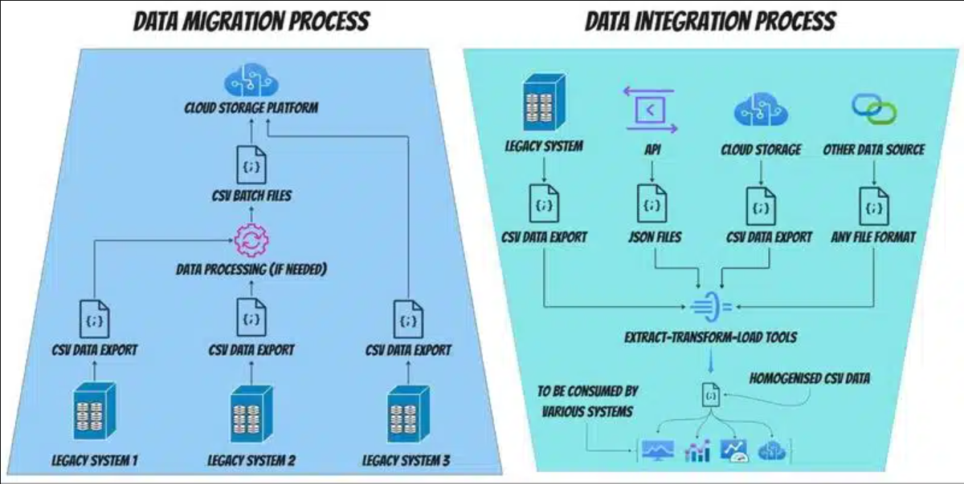
CSV’s Pros & Cons
PROS
- CSV files are easily made and are compatible with most software and systems.
- They’re easy for you and I (humans) to read and edit without specialized software.item
- CSVs allow fast reading and processing due to their plain text and lack of complexity.
- CSV files can represent large datasets in a more compact form than JSON and XML, allowing for smaller files.
- CSV files work well with Microsoft Excel and Google Sheets, which are widely used.
CONS
- They’re unsuitable for hierarchical or nested data and lack metadata support.
- CSVs lack data type support, leading to potential misinterpretations.
- You won’t be able to include comments or annotations within the data.
- If you use commas within data fields in CSV, it can cause confusion because commas are used for value separation.
- They do NOT work well with APIs because of poor interoperability.
What is a JSON file?
JSON is a widely used data format in modern web development that’s perfect for storing data and transmitting it between servers and clients. It has a key and value pair structure that is organized in objects and arrays. They are the unseen heroes of the internet, working for you every time you log on.
The data is structured as a collection of objects enclosed in curly braces { }. Each object contains key and value pairs that describe the dimension and value that goes with it. This array of objects is marked by square brackets [ ]. JSON can handle multiple sets of data in a clean, structured format, and this makes it easy to parse and analyze the data.
You can structure data in multiple ways with JSON. You can nest data using various key naming conventions, (for more complex data than in this example), and you can pick data types that make sense for your dataset. You can also add metadata to your JSON, making it easier to track and manage.
In a nutshell, JSON is the SUV of the data file format world. It’s easy to drive, fairly quick, and while you couldn’t put a refrigerator in one, it’s able to carry a variety of items easily.
Common JSON uses:
Web development, APIs and RESTful services
NoSQL databases
Because JSON has no predefined schema, it’s ideal for document-based NoSQL databases, like MongoDB, Firebase, and CouchDB, that are designed for dynamic and evolving data models. This flexibility is useful for applications like social media platforms where user-generated content like posts and comments require adaptability. JSON also allows developers to add or modify fields which simplifies migrations and speeds development.
JSON’s Pros & Cons
PROS
- JSON is widely compatible and adopted across web technologies and APIs.
- Natively supported by JavaScript.
- Compared to XML, JSON has a large community support and a lower learning curve.
- It’s more widely adopted in SQL in modern databases than XML and CSV.
- JSON supports hierarchical and nested structures yet is less bulky than XML.
CONS
- Less readable (for more complex files) and harder to understand quickly compared to CSV.
- JSON can be slower to parse for large datasets than CSV, but not XML.
- High overhead because of the complexity and nested structure compared to CSV.
- More limited Data Types than XML.
- While JSON schemas exist, they’re not widely used and lack the support that XSD enjoys.
What is an XML file?
As I’ve mentioned, XML data format can represent complex data structures. It does this with a hierarchical, tag-based approach where each piece of data is enclosed within descriptive tags, forming a tree-like structure that mirrors the relationships between the different elements.
This self-descriptive feature allows for detailed metadata and defined data relationships, which makes it highly suitable for applications that need to work across different systems. It’s able to use strict schemas based on XSDs, allowing enforced data structure and validation rules.
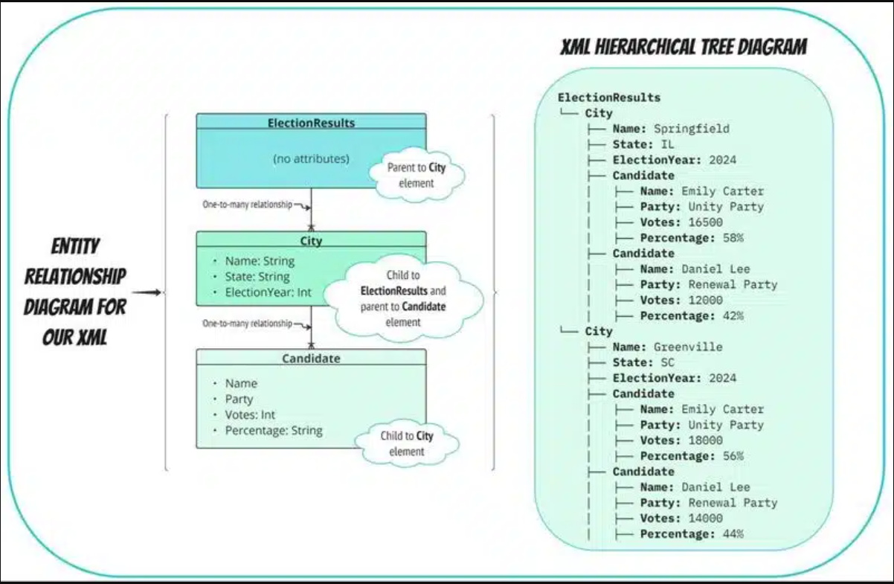
XML’s Pros & Cons
PROS
- XML provides a consistent format for data exchange, great for uniformity across systems with industry standards. Using XSD gives extra validation capabilities as well.
- XML supports hierarchical, data structures like standardized metadata syntax.
- You can take advantage of robust validation with schemas like XSDs and DTDs (or legacy schema).
- XML Defines rich data types, which is good for validation and security with XSD.
- Their structure and capabilities are ideal for SOAP protocol, which is used for secure, complex, and reliable enterprise environments when needed.
- If you pair XML with XSLT templates, you can transform data into other formats, like HTML, other XML schemas, or plain text.
CONS
- Due to extensive tagging, XML files are big and wordy, compared to the compact structure of JSON and the simple, no-tag format of CSV.
- Your storage needs will increase significantly with data size, especially compared to CSV and JSON.
- You’ll find XML harder to understand, especially with heavily nested architectures.
- The extensive markup is harder to parse, leading to slower transmission and processing times.
- JSON is more prevalent in RESTful services than XML because of JSON’s smaller structure and faster processing.
- While it’s still widely used in certain niches, its wordy syntax and larger size make it less efficient for simple data exchange scenarios than JSON.

